1. **Perform basic Image Handling and processing operations on the image• Read an image in python and Convert an Image to show outline using Canny function**

**Aim:**

To Perform Basic Operations to Convert image to show outline Canny function in Python.

**Code:**

import cv2

import numpy as np

kernel = np.ones((5,5),np.uint8)

print(kernel)

path = "C:\\Users\\prith\\Pictures\\Saved Pictures\\cvimage.jpg"

img = cv2.imread(path)

imgGray = cv2.cvtColor(img,cv2.COLOR_BGR2GRAY)

imgBlur = cv2.GaussianBlur(imgGray,(7,7),0)

imgCanny = cv2.Canny(imgBlur,100,200)

cv2.imshow('Canny Edge Detection',imgCanny)

cv2.waitKey(0)

cv2.destroyAllWindows()

**Input:**

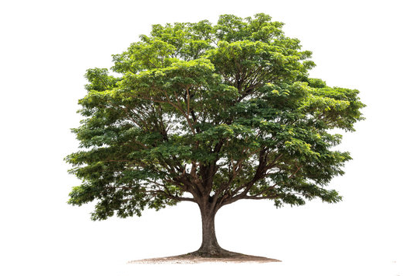

**Output:**

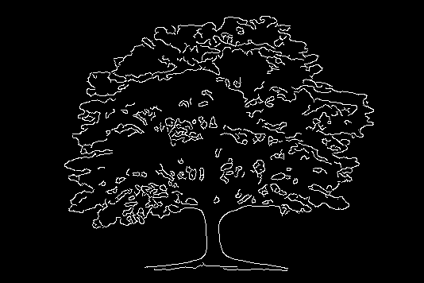

**Result:**

The python program to convert image to outline using canny function.